User Manual

Year: 2018 Semester: Fall Team: 07 Project:Handi_glove

Creation Date: November 14th, 2018 Yaodong Shen Last Modified: November 16th, 2018

Member 1: Yaodong Shen Email: shen234@purdue.edu

Member 2: Jia En Chua Email: chuaj@purdue.edu

Member 3: Yao Chen Email: chen1748@purdue.edu

Member 4: Carol Lo Email: lo40@purdue.edu

Assignment Evaluation:

|  |  |  |  |  |
| --- | --- | --- | --- | --- |
| **Item** | **Score (0-5)** | **Weight** | **Points** | **Notes** |
| **Assignment-Specific Items** | | | | |
| **Product Description** | 4.5 | x1 | 4.5 |  |
| **Product Illustration** | 5 | x2 | 10 |  |
| **Setup Instructions** | 4.5 | x3 | 13.5 |  |
| **Usage Instructions** | 4.5 | x3 | 13.5 |  |
| **Troubleshooting Instructions** | 4.5 | x3 | 13.5 |  |
| **Writing-Specific Items** | | | | |
| **Spelling and Grammar** | 3.5 | x2 | 7 |  |
| **Formatting and Citations** | 5 | x1 | 5 |  |
| **Figures and Graphs** | 5 | x2 | 10 |  |
| **Technical Writing Style** | 4 | x3 | 12 |  |
| **Total Score** | 89 | | |  |

5: Excellent 4: Good 3: Acceptable 2: Poor 1: Very Poor 0: Not attempted

Comments:

*Your product illustration looks good. Please check the comments for the other sections.*

1. Product Description

Handi_glove is a wearable technology that can be used to remotely control a robotic hand. This project is designed to protect researchers and industry workers when working in hazardous environments. For example, there are scientists who are diagnosed with serious health issues after years of inhaling poisonous gas when they conduct experiments. This can be avoided by using Handi_glove. Researchers do not have to be in contact with the experiment tools by using Handi_glove. In addition, there are temperature and pressure feedback systems installed on the glove. Scientists do not have to compensate the precision of heat sensation by using this project. They will have real-time feedback about the temperature and pressure of what they are holding. This will enhance the efficiency of conducting experiments. For instance, on the space mission, astronauts can fix the spacecraft or check the elements outside the craft. Below is a list of items that are already installed on Handi_glove which help to complete all functionalities.

* Robotic hand
* Glove with exoskeleton attached
* STM32L152ZET6
* Potentiometer
* Temperature and Pressure Sensor
* Servo motor
* Linear Actuator
* Syringe, Airbag

Handi_glove can be broken down into two parts to help better understand how to operate it. The first part is the glove that transmits data related to the user’s hand gesture movement and provides temperature and pressure feedback to the user. The second part is the robotic hand that receives data from the glove and moves the robotic fingers accordingly and transmits the temperature and pressure sensor value to the glove for the feedback system. Both parts utilize STM32L152ZET6 and communicate with each other via the UART module. We have also added a unique feature that can reset the robotic hand, the temperature and pressure feedback system back to a default setting once the user’s hand leaves the glove. The system will only be active again when the glove is in use.

1. Product Illustrations

***The robotic hand control board***

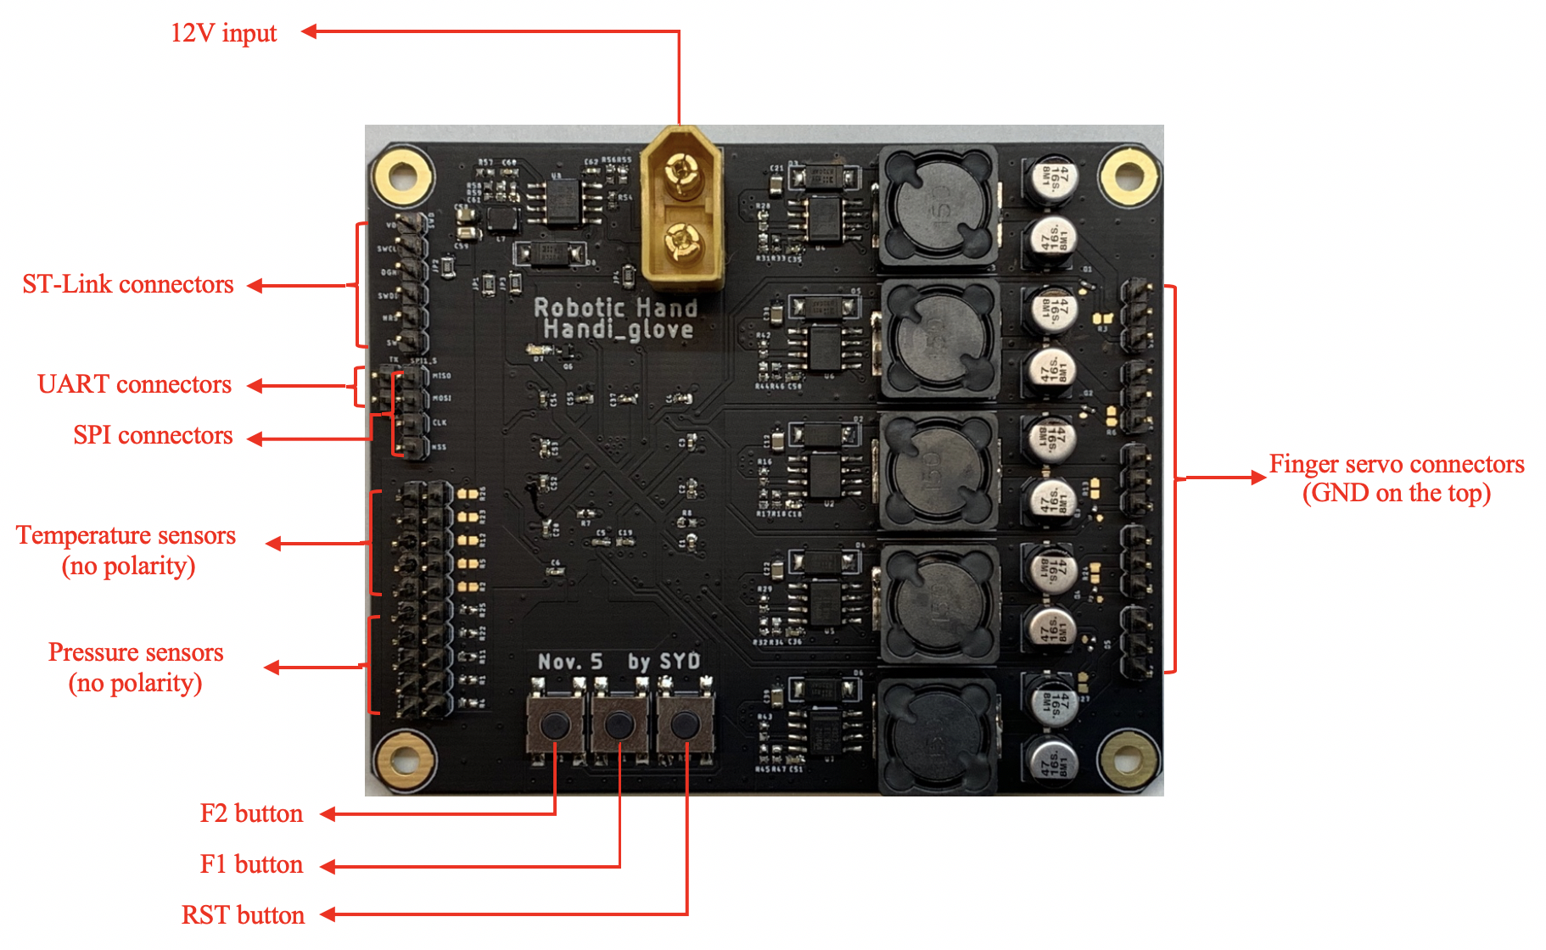

***Glove control board***

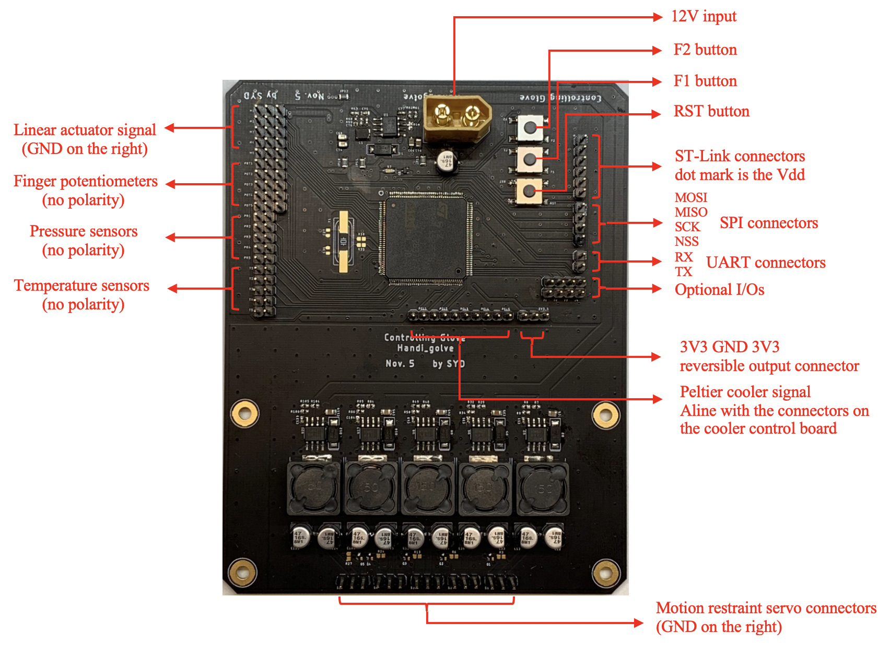

***Side view of controlling glove***

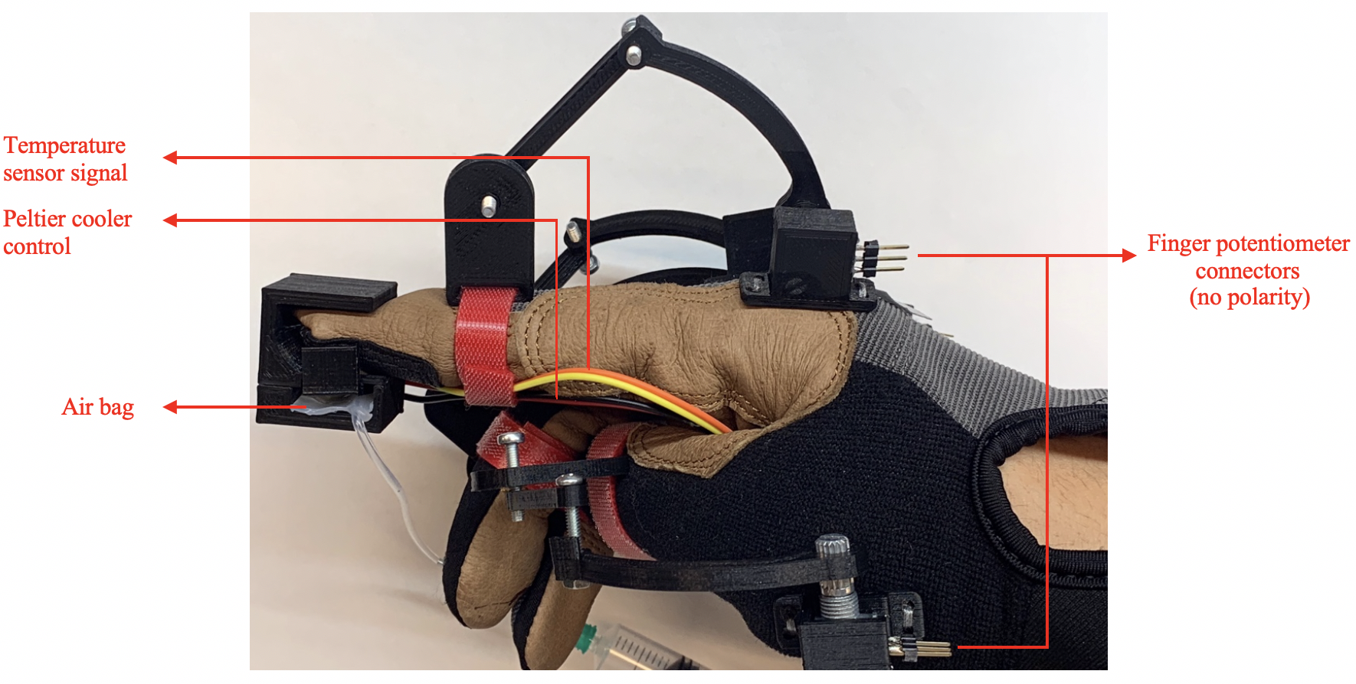

***Top view of controlling glove***

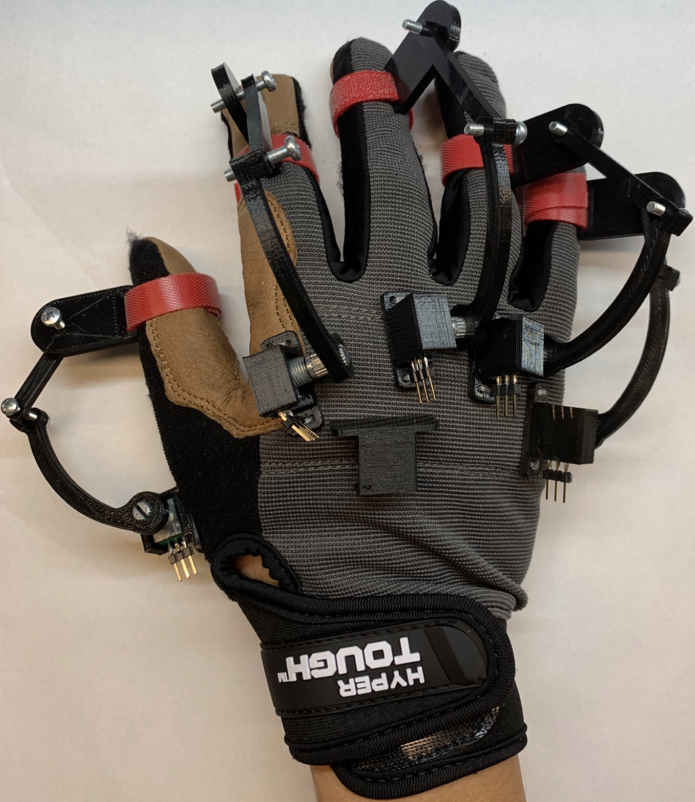

Pressure system

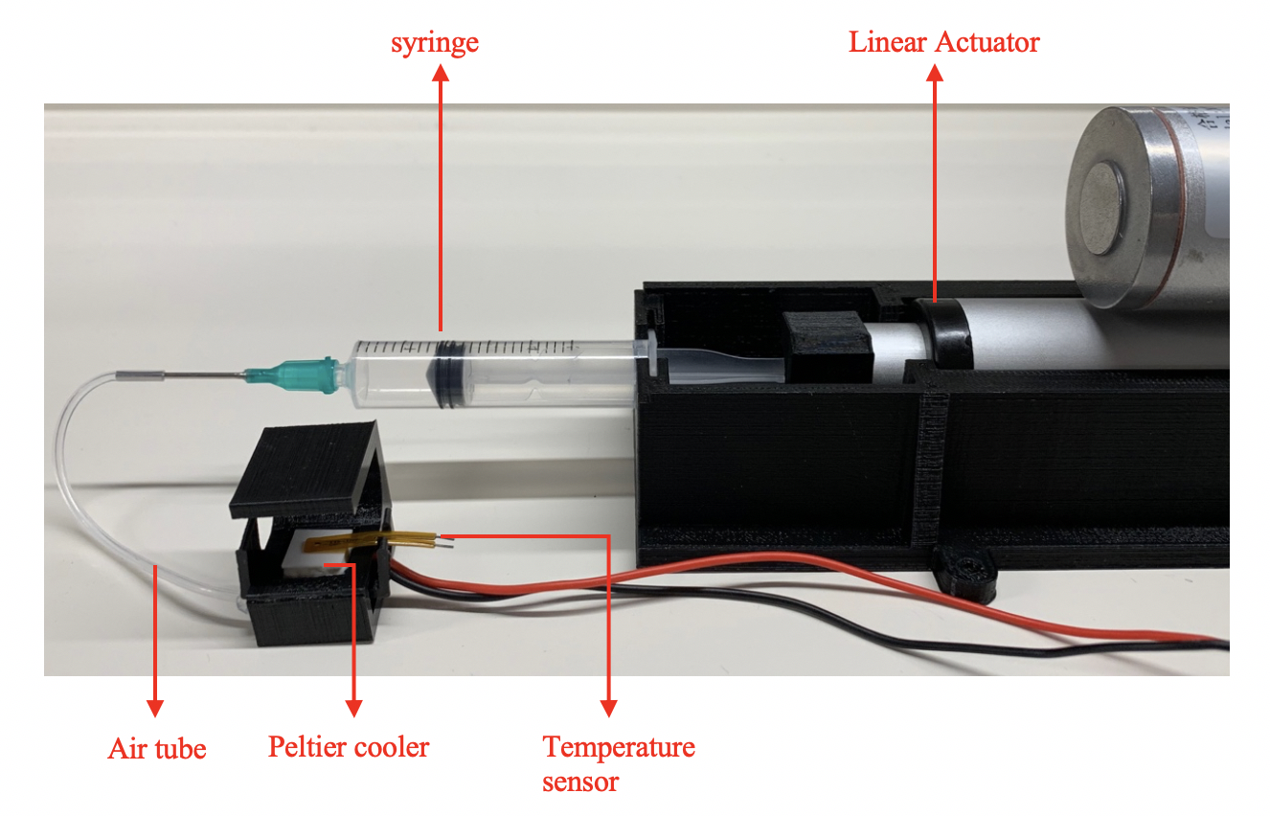

Robotic hand fingertip sensors

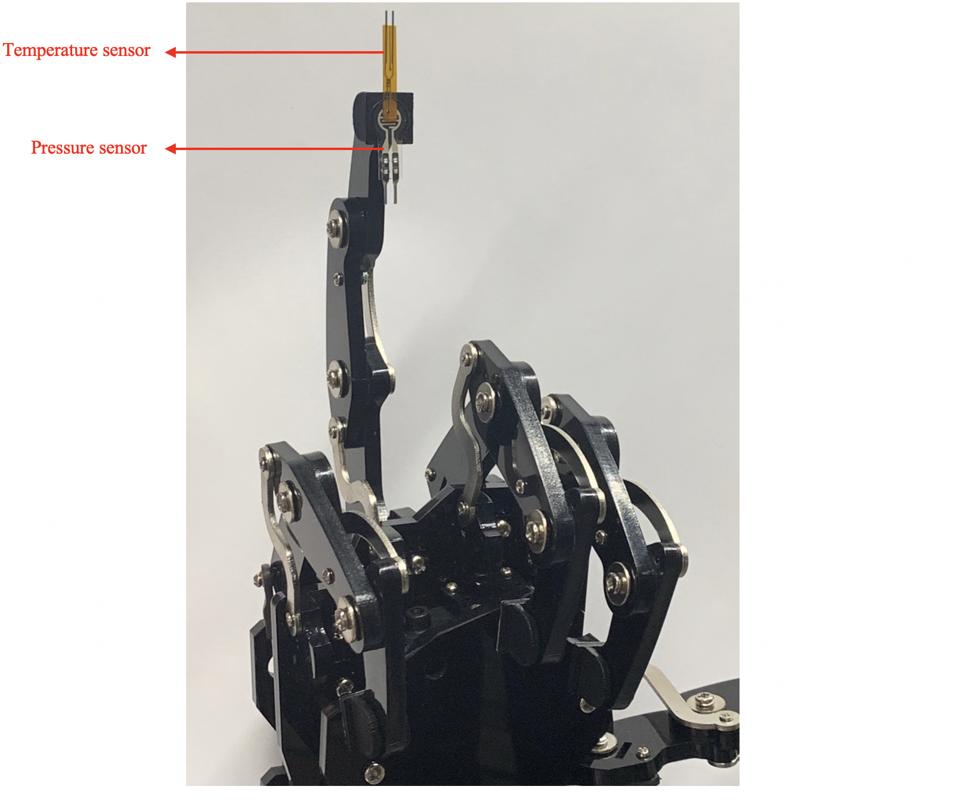

1. Setup Instructions

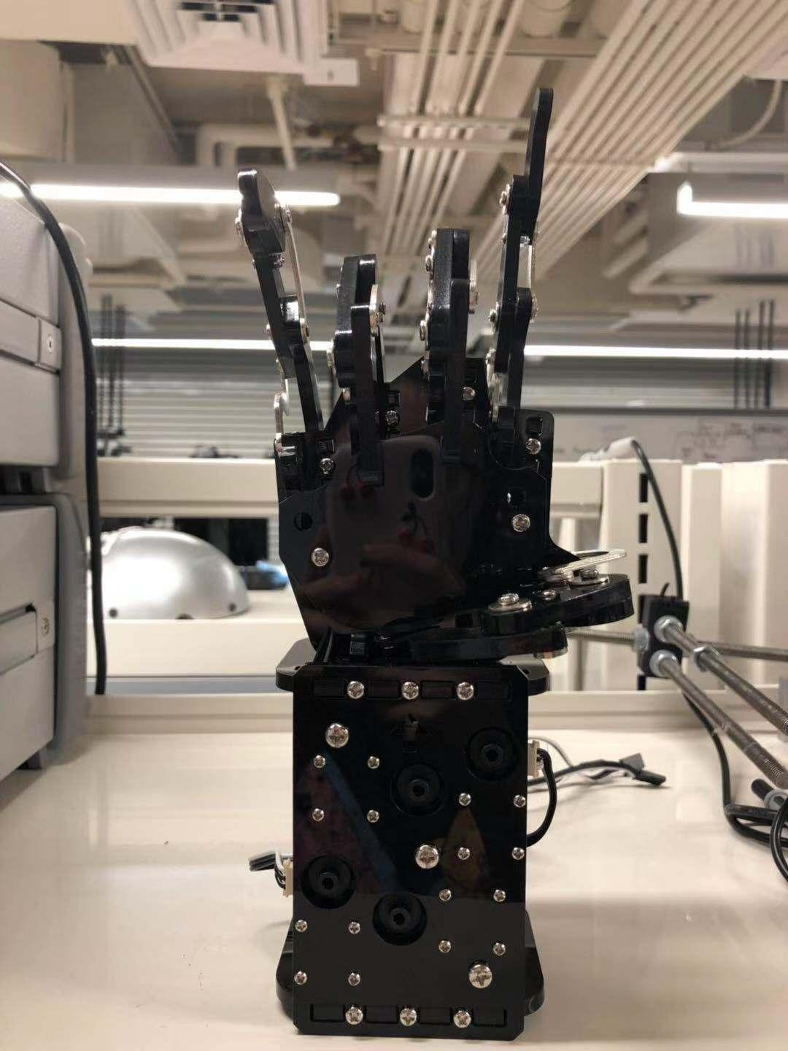

1. Assemble the **mechanical robot** hand first

2. Install the **temperature sensor** and **Peltier cooler** on the robot hand.

3. Install the **airbag** and **Peltier cooler** in the **3D printed model holder**

3. Connect the pressure **linear actuator** in the holder with the **finger-tip holder** of the glove

4. Mount the 3D printed holder at the top of glove. After that, the user can feel the temperature and pressure feedback **via the fingertip**

6. Connect the temperature part and **test** it

7. Connect the pressure part and **test** it

8. Connect all devices to the **power source**

9. Wear the glove to control our robot hand and **enjoy** the cool features it provides!

*assemble the mechanical robot hand*

1. Usage Instructions

General Usage

1. The device comes with a **robotic arm** and a **user-controlled glove**.
2. Insert your right hand into the **user-controlled glove**.
3. Make sure that the *second joint* of each finger is properly secured inside of the velcro loop.
4. Tighten the velcro piece by your wrist. Please ensure that all components attached to your wrist and joints are tight and secure.
5. Insert every finger into the corresponding **finger-tip holder** of the glove.
6. Ensure that the tips of your fingers are secured in the **finger-tip holder**. You may insert additional padding if it feels loose.
7. Plug in power for both the **robotic arm** and the **user-controlled glove**.
8. You may now move your fingers and control the robotic arm.
9. Troubleshooting Instructions

* **Robotic finger does not move?**

Straighten all fingers and slowly move them to allow communication between two microcontrollers to take place.

The step to assemble the mechanical robot may have the problem. Users should rebuild it and follow the correct step.

The charger for the power has some problem. Users should check about the power sources.

* **Linear actuator generates beep sound?**

Release the pressure sensor from the object by using the glove to control robotic finger remotely. This is due to the linear actuator generating overwhelming force on the airbag. If the above solution does not solve the problem. Then, leave the glove empty and press the black push button on both microcontrollers.

* **The robotic finger moves in the wrong direction?**

Swap both outer pins of a potentiometer which resides on the glove.

* Airbag does not inflate?

Try touching the pressure sensor and see if the linear actuator moves. If it does, check if the airbag is broken. Otherwise adjust syringe’s position back to 1 millimeter.

* **Temperature module does not provide correct temperature?**

Try replacing the temperature sensor with the backup sensor that we provide in the box. If there is no change of temperature at all, please change the heat generator with the extra unit that we provide in the box. These items can also be purchased on <https://engineering.purdue.edu/477grp7/inquiry>.

* **None of the above help?**

Unplug the main power supply and reattach it. Reset both microcontrollers by pressing the black push button on board.

* **Can’t find your question here?**

Please contact us at <https://engineering.purdue.edu/477grp7/inquiry>. Leave your message and contact information so that our friendly and knowledgeable customer service can get back to you as soon as possible.